Web Application Development Lab 01 Report
  - Student Name: Vũ Quốc Khánh
ID: ITCSIU24039
Date: March 4, 2026

Exercise 1

HTML Code
<!DOCTYPE html>
<html lang="en">
<head>
<meta charset="UTF-8">
<meta name="viewport" content="width=device-width, initial-scale=1.0">

<!-- Search Engine Optimization (SEO) tags -->
<meta name="author" content="Vu Quoc Khanh">
<meta property="description" content="An example Curriculum Vitae (CV) using only HTML">
<meta property="keywords" content="cv, example-cv, html-only-cv">

<!-- Open Graph (OG) tags for Social Media sharing -->
<meta property="og:title" content="HTML-only CV" />
<meta property="og:description" content="An example Curriculum Vitae (CV) using only HTML">

<link rel="icon" href="./favicon.png">

<title>HTML-only CV</title>
</head>
<body>
<hr>

<h1>Your Name</h1>
<p class="job-title">Junior Frontend Developer</p>

<div>
<div>123 Your Street</div>
<div>Your City, ST 12345</div>
<div>(123) 456-7890</div>
<div>no_reply@example.com</div>
</div>

<h2>Skills</h2>
<p>HTML, CSS, JavaScript, Accessibility, Figma to Design, Responsive Web Design, Technical Writing, Presentation</p>

<h2>Education</h2>
<h3>School Name, Location - Degree</h3>
<p>Month 20xx to Month 20xx</p>
<p>List of exciting things you did at university</p>

<h2>Experience</h2>

<h3>Company Name, Location - Job Title</h3>
<p>Month 20xx to Month 20xx</p>
<ul>
<li>List of achievements</li>
<li>List of achievements</li>
<li>List of achievements</li>
</ul>
<p>Skills: List of skills used or gained at this company</p>

<h3>Company Name, Location - Job Title</h3>
<p>Month 20xx to Month 20xx</p>
<ul>
<li>List of achievements</li>
<li>List of achievements</li>
<li>List of achievements</li>
</ul>
<p>Skills: List of skills used or gained at this company</p>

<h2>Across the internet</h2>
<p>Add your LinkedIn, Github profile links</p>
</body>
</html>

Result
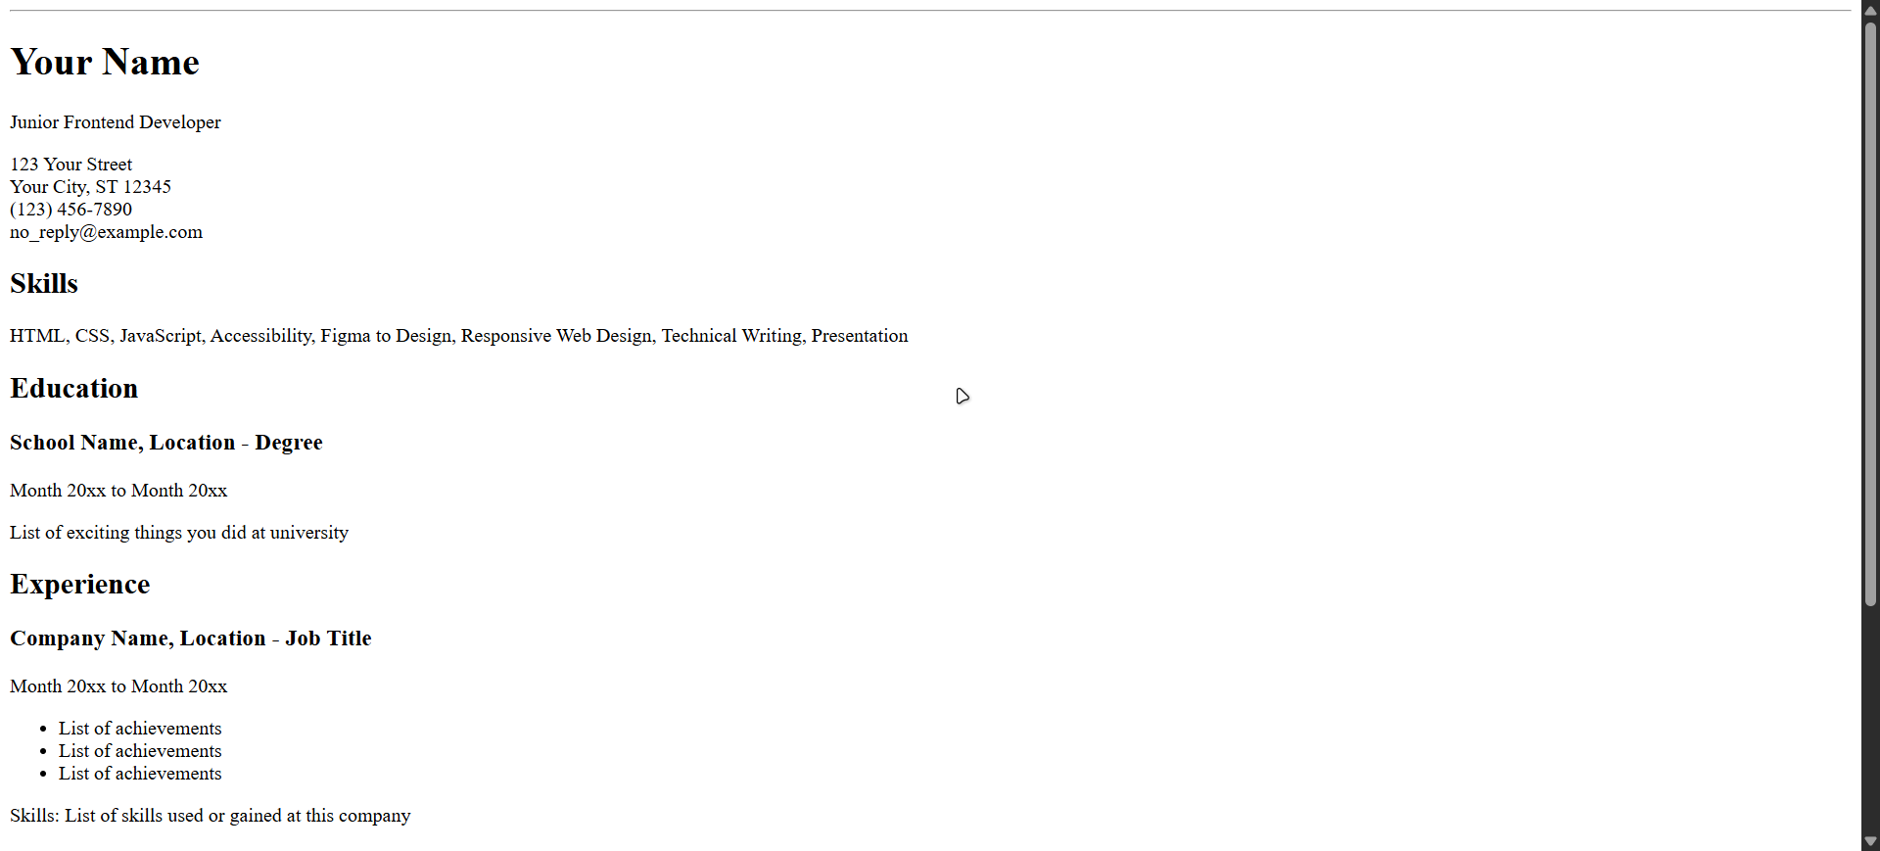

Exercise 2

SQL Code
DROP DATABASE IF EXISTS WebAppExercise01;

CREATE DATABASE WebAppExercise01;

USE WebAppExercise01;

CREATE TABLE Student(
StudentID INT UNIQUE NOT NULL,
StudentName VARCHAR(30),
DoB DATE,
Major VARCHAR(50),
PRIMARY KEY (StudentID)
);

CREATE TABLE Course(
CourseID INT UNIQUE NOT NULL,
CourseName VARCHAR(50),
PRIMARY KEY (CourseID)
);

-- Student and Course have many-to-many relationship
CREATE TABLE StudentRegisterCourse(
StudentID INT,
CourseID INT,
FOREIGN KEY (StudentID) REFERENCES Student(StudentID),
FOREIGN KEY (CourseID) REFERENCES Course(CourseID)
);

CREATE TABLE Department(
DepartmentID INT UNIQUE NOT NULL,
DepartmentName VARCHAR(100),
PRIMARY KEY (DepartmentID)
);

CREATE TABLE Lecturer(
LecturerID INT UNIQUE NOT NULL,
LecturerName VARCHAR(30),
DepartmentID INT,
PRIMARY KEY (LecturerID),
FOREIGN KEY (DepartmentID) REFERENCES Department(DepartmentID)
);

-- Lecturer and Course have many-to-many relationship
CREATE TABLE LecturerTeachCourse(
LecturerID INT,
CourseID INT,
FOREIGN KEY (LecturerID) REFERENCES Lecturer(LecturerID),
FOREIGN KEY (CourseID) REFERENCES Course(CourseID)
);

INSERT INTO Student VALUES
(1, "John Doe", '2006-01-01', "Computer Science"),
(2, "Jane Doe", '2006-01-02', "Information Technology");

INSERT INTO Course VALUES
(1, "C/C++ Programming"),
(2, "Introduction to Computing");

INSERT INTO Department VALUES
(1, "Computer Science and Engineering"),
(2, "Economics, Finance, and Accounting");

INSERT INTO Lecturer VALUES
(1, "Alan", 1),
(2, "Lily", 2);

INSERT INTO StudentRegisterCourse VALUES
(1, 1),
(1, 2),
(2, 1),
(2, 2);

INSERT INTO LecturerTeachCourse VALUES
(1, 1),
(2, 2);

